Login to Canvas

Create a Blank Course Shell

* From Dashboard in upper right select **Start a New Course** and give it a name
* From Courses choose All Courses link then select **+ Course** and give it a name

Choose **Commons** button on left side menu in Canvas

(Authorize access if asked)

In **Commons** type in **Nevada Donor** in the **Search** bar

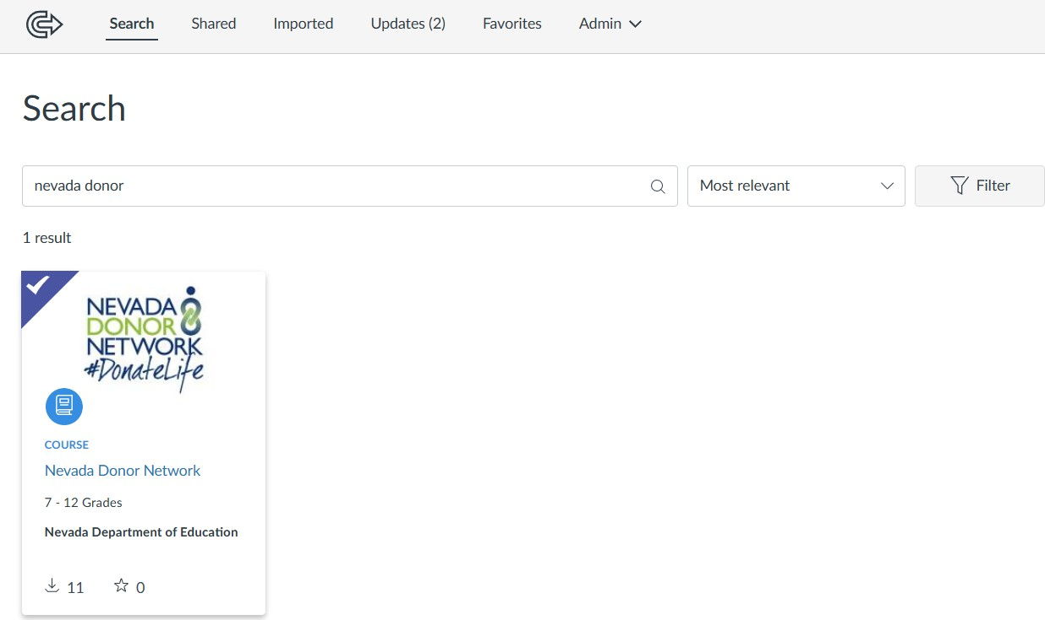

Click on the course to open

Select **Import/Download** button on right side

Choose the name of the course to import to

Choose to **Import into Course** button

* message will appear in green indicating the import is occurring

Go to **Dashboard** and wait for the course to import (about 2-5 minutes)

Select the course you imported into

Choose **Modules** link on left to access content and go through the content